Deloitte Case Study

**Objective:**

Understanding a country's financial and economic condition is crucial for investors, policymakers, and financial institutions. This analysis focuses on evaluating various economic indicators such as CPI (Consumer Price Index), exchange rates, and export merchandise to gain insights into a country's economic health.

In conclusion, analyzing CPI, exchange rates, and exports provides a comprehensive view of a country's economic landscape, guiding decision-making processes for governments, businesses, and investors.

**Benefits:**

Analyzing Consumer Price Index (CPI), exchange rates, and exports of a country provides valuable insights into its economic health, performance, and potential challenges. Here are some benefits of analyzing these key indicators:

1. **Economic Stability Assessment**:
   * **CPI**: Helps gauge inflationary pressures and the cost of living. A stable CPI indicates economic stability, while a rising CPI may signal inflationary pressures.
   * **Exchange Rate**: Indicates the strength of a country's currency relative to other currencies. A stable or strong exchange rate can attract foreign investments and boost economic confidence.
   * **Exports**: Reflects the country's competitiveness in global markets. Growing exports can lead to increased foreign exchange earnings and economic growth.
2. **Policy Formulation**:
   * Insights from these indicators help policymakers formulate effective monetary, fiscal, and trade policies to address economic challenges and promote growth.
3. **Investment Decisions**:
   * Investors use these indicators to assess the economic environment and make informed decisions about investing in a country's financial markets, real estate, or businesses.
4. **Trade Balance Analysis**:
   * Monitoring exports alongside exchange rates can help analyze a country's trade balance. A positive trade balance (more exports than imports) is generally favorable for economic growth.
5. **Currency Risk Management**:
   * Businesses can manage currency risks by analyzing exchange rate fluctuations and planning their import/export strategies accordingly.
6. **Competitive Positioning**:
   * Analyzing exports can help identify sectors where a country has a competitive advantage. This insight can guide economic development strategies and encourage investments in key sectors.
7. **Inflation Forecasting**:
   * CPI data is crucial for forecasting inflation trends, allowing businesses and consumers to anticipate future price changes and adjust their financial plans accordingly.
8. **Consumer and Business Confidence**:
   * Stable CPI and exchange rates, along with growing exports, can boost consumer and business confidence, leading to increased spending, investments, and economic activity.
9. **Global Economic Integration**:
   * Understanding these indicators is essential for countries participating in global trade and finance, facilitating better economic integration and cooperation with international partners.

**Data Transformation:**

First, for all three files—CPI, exchange rate, and merchandise exports—any missing values should be filled using backfill and forward fill methods. This is because these variables, namely CPI, exchange rate, and merchandise exports, often exhibit a growing trend or remain stable over time. Therefore, the most suitable approach to impute missing values is to use the nearest available value.

Once the data is imported into Power BI, apply DAX formulas to calculate the annual growth rate and monthly growth rate. Finally, employ visualization techniques to create a comprehensive report for analysis.

**Final Report :**

Annually

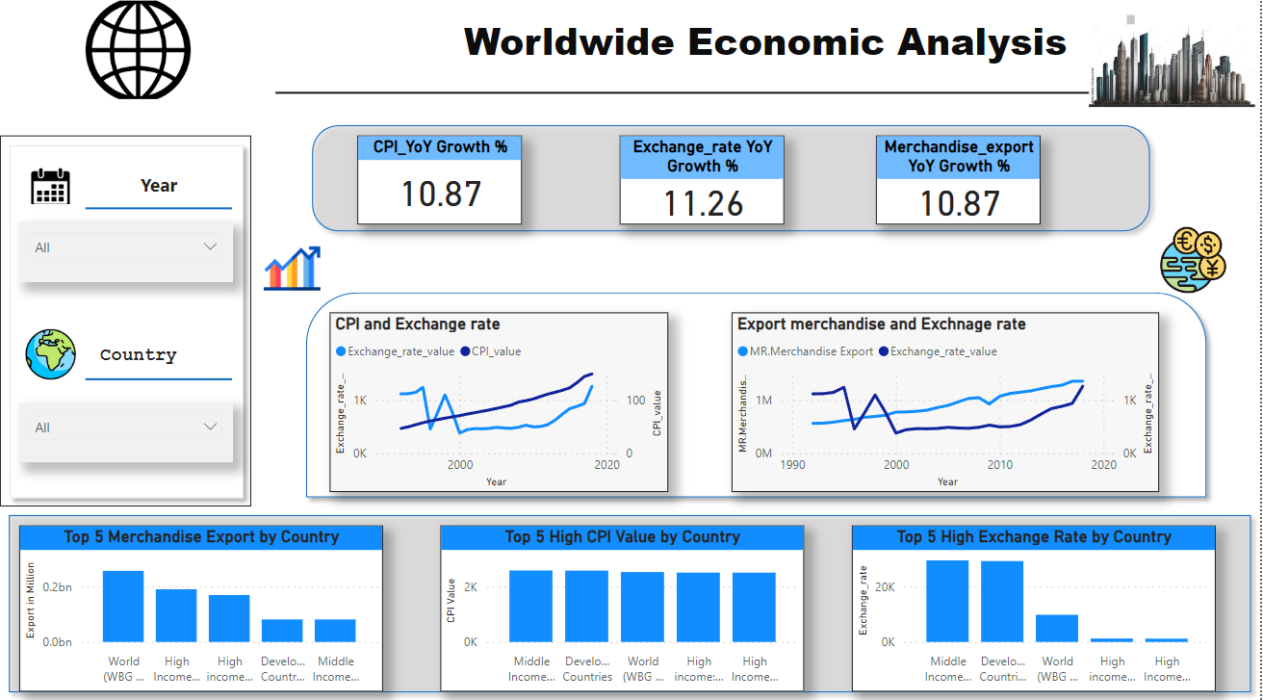

Monthly

